ggplot(iris, aes(x = Sepal.Length, y = Sepal.Width))+ geom_point()

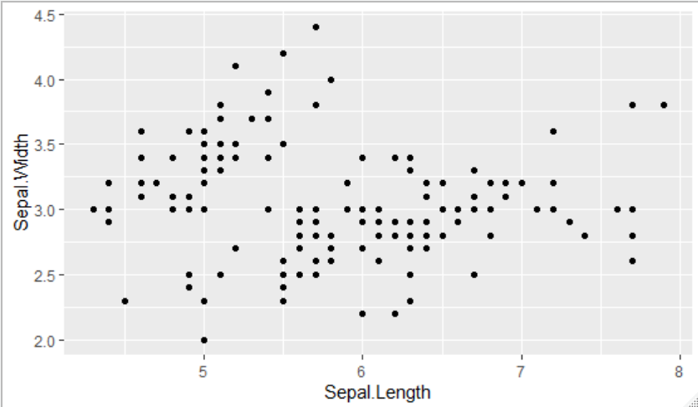

ggplot(iris, aes(x = Sepal.Length, y = Sepal.Width))+ geom_jitter(alpha = 0.6)

